Lab 4

# Qs.1 multiple of 3?

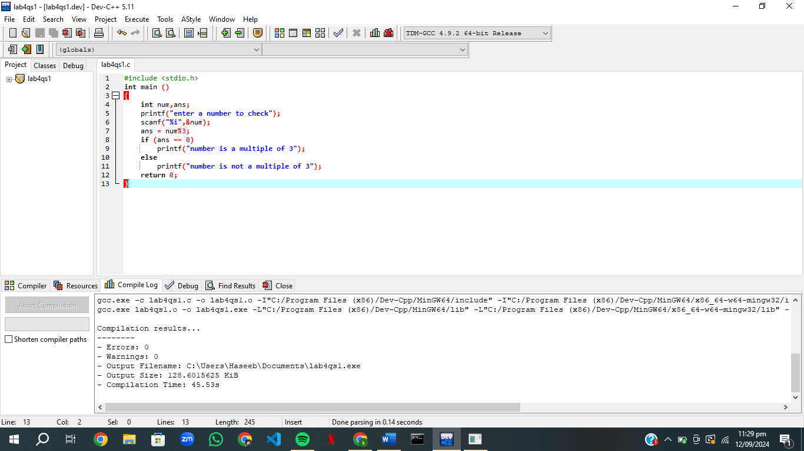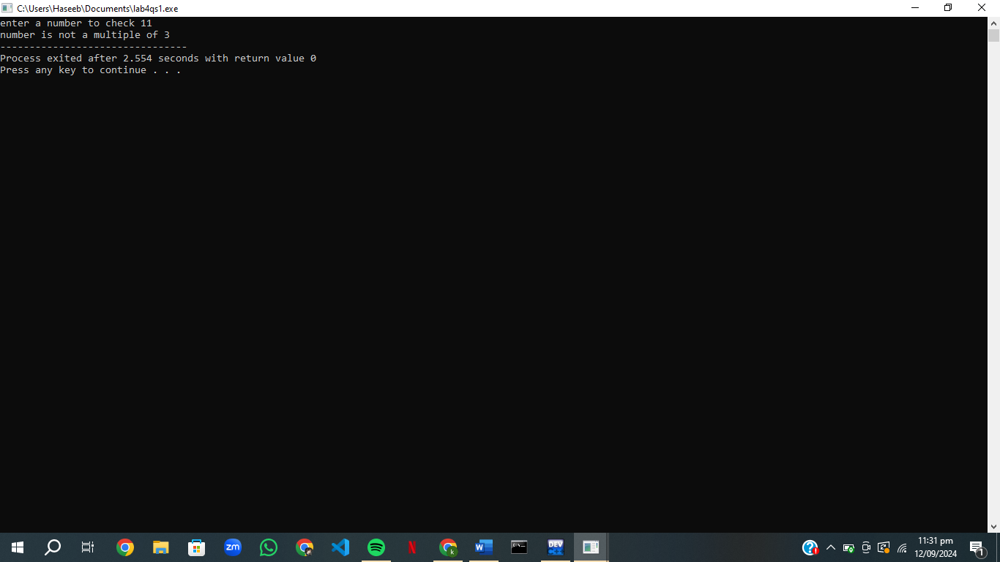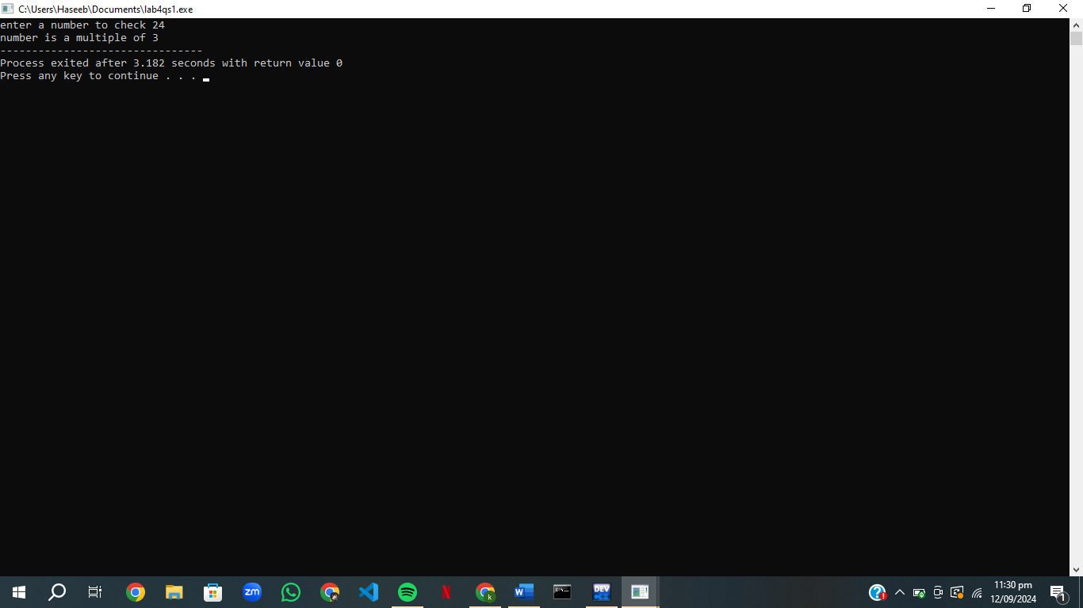

start

It is a multiple

Not a multiple

Is ans = 0?

ans num/3

Enter num to check

NO

YES

end

# Qs.2 Calculator

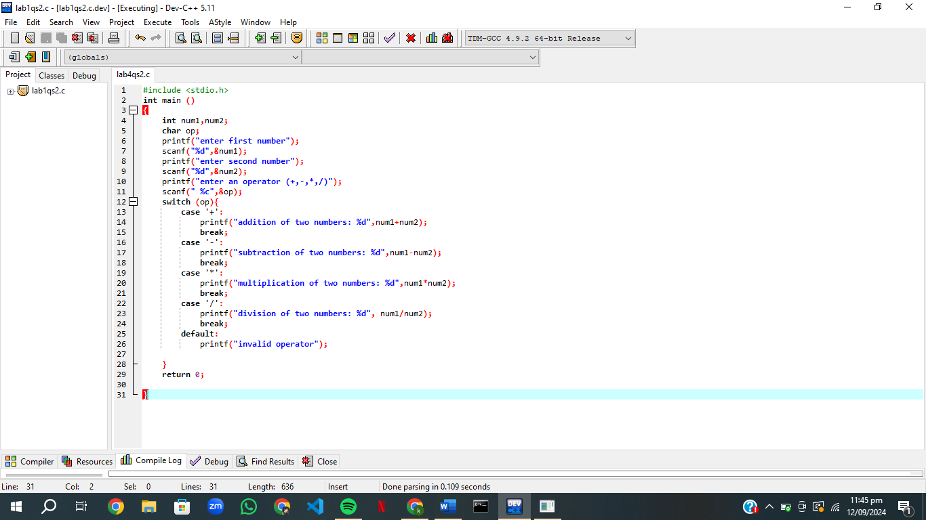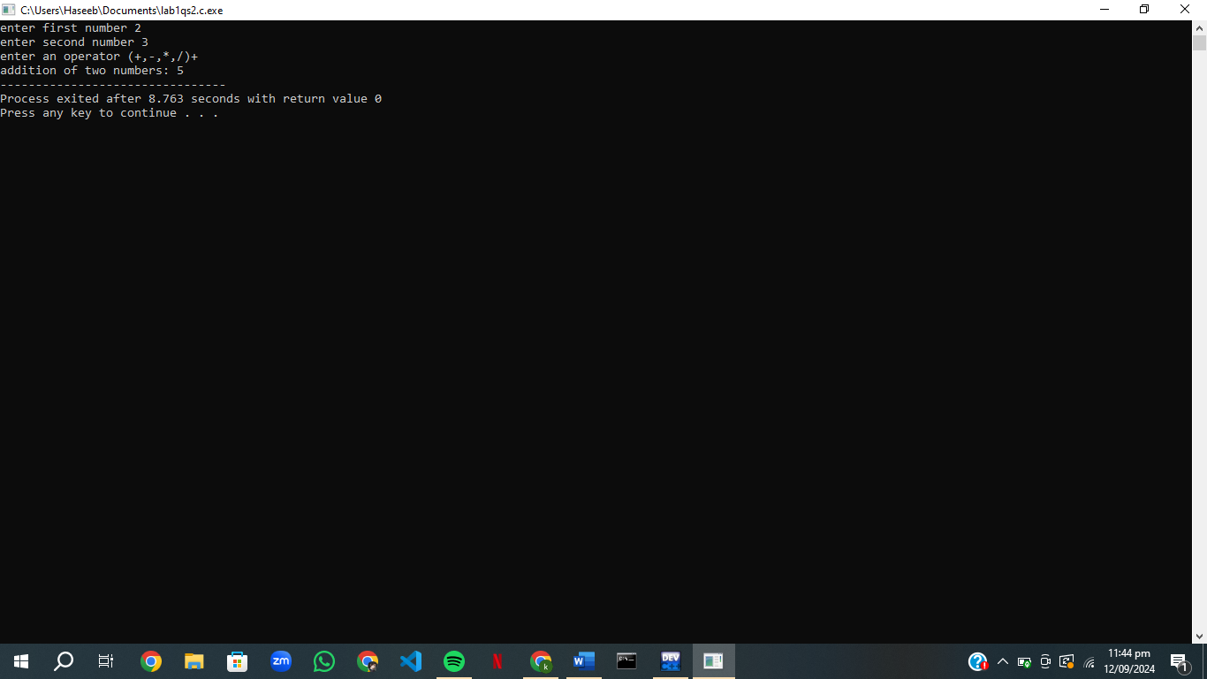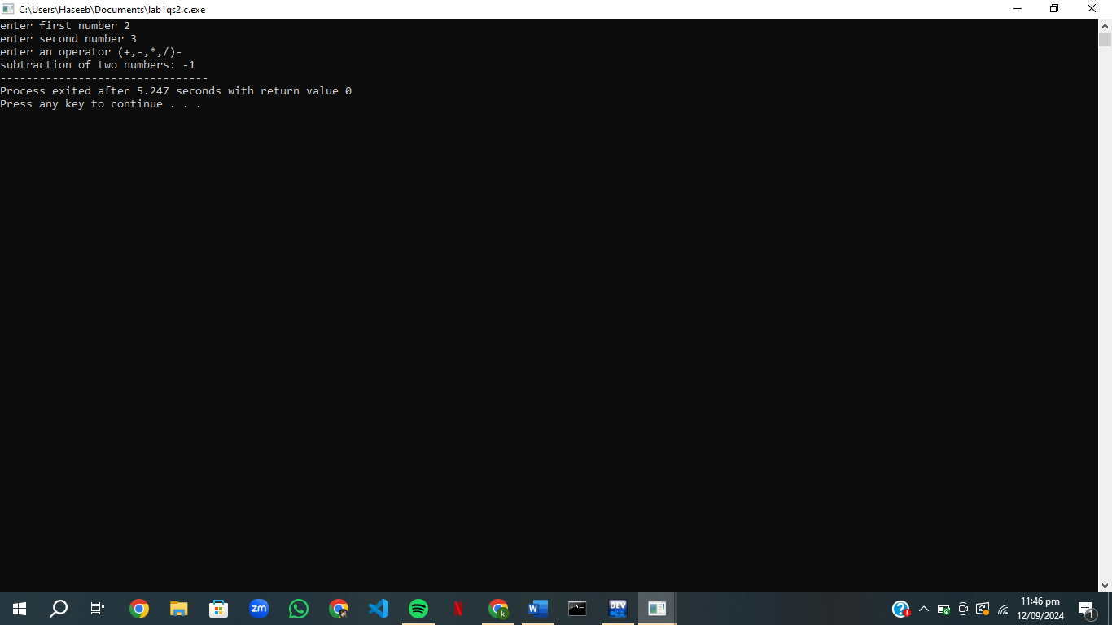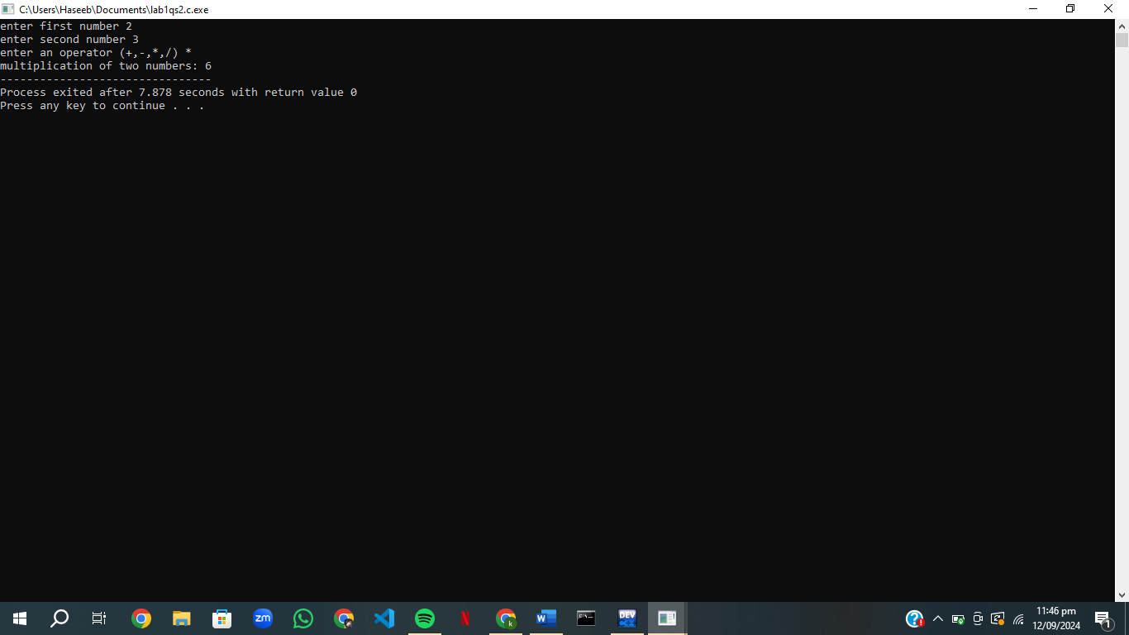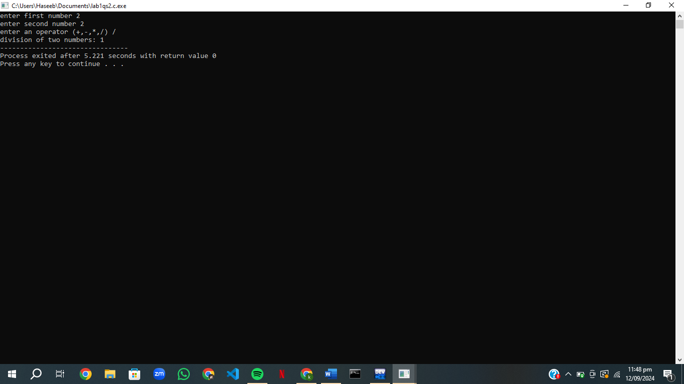

Is operator = ‘+’?

Enter num1,num2,operator

start

Is operator=’/’?

Is operator = ‘*’?

Is operator =’-‘?

NO NO NO NO

YES YES YES YES

End

Invalid operator

Ans= num1*num2

Ans=num1/num2

Ans =num1-num2

Ans =Num1+num2

# Qs.3checking characters

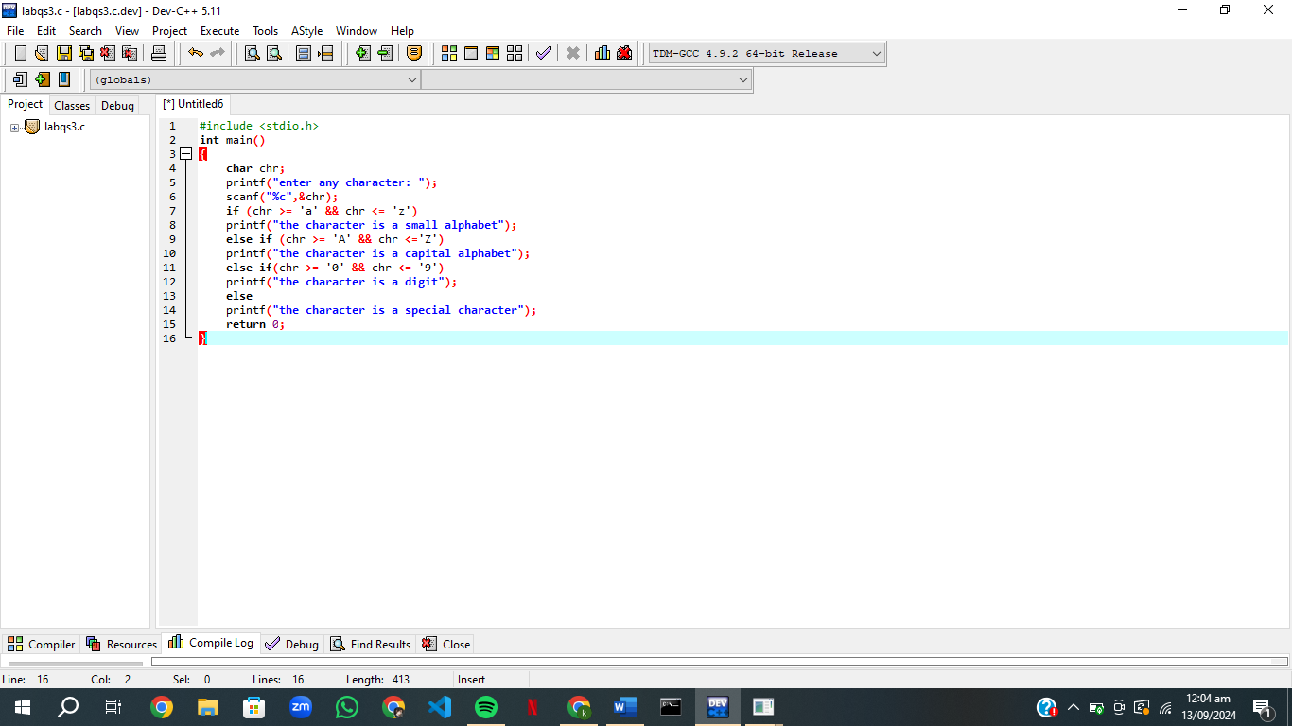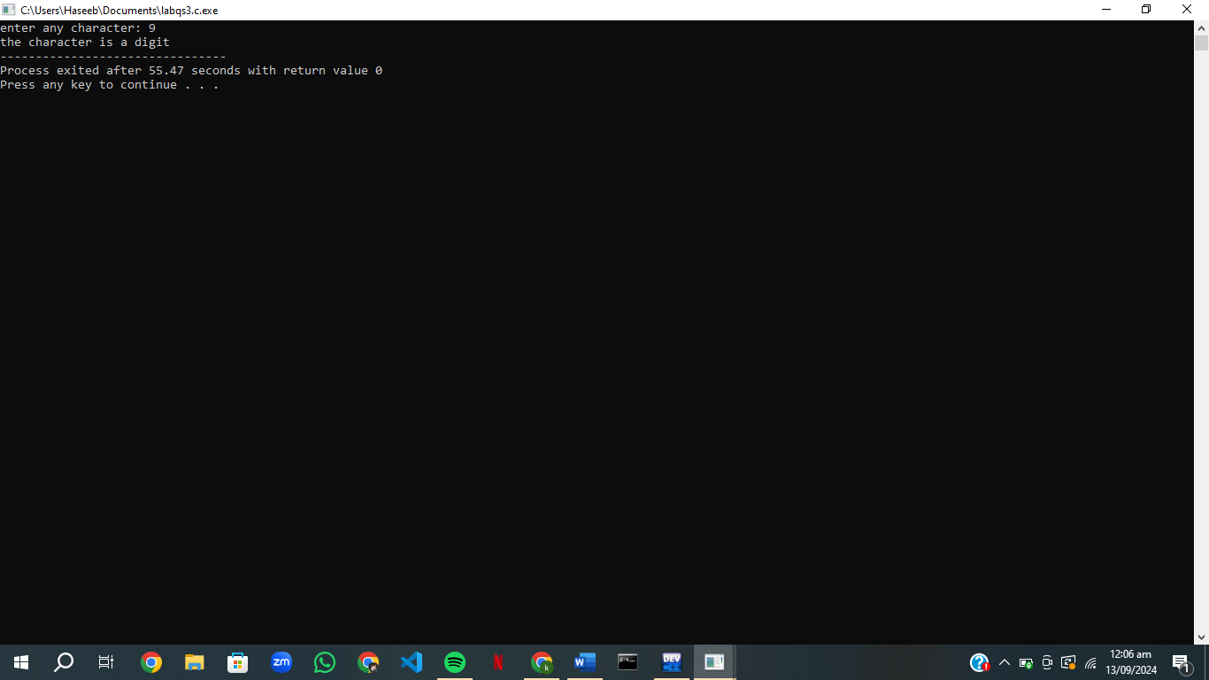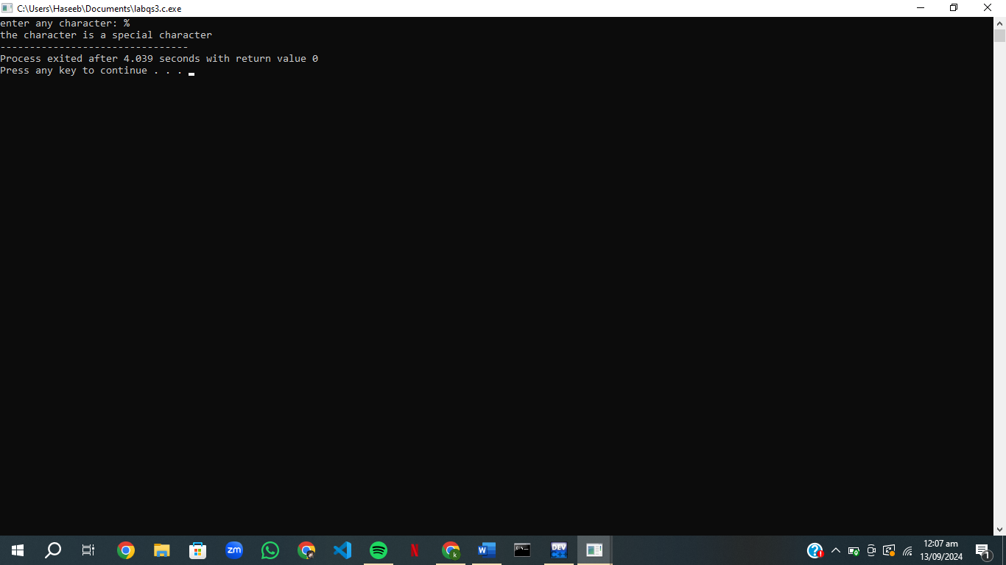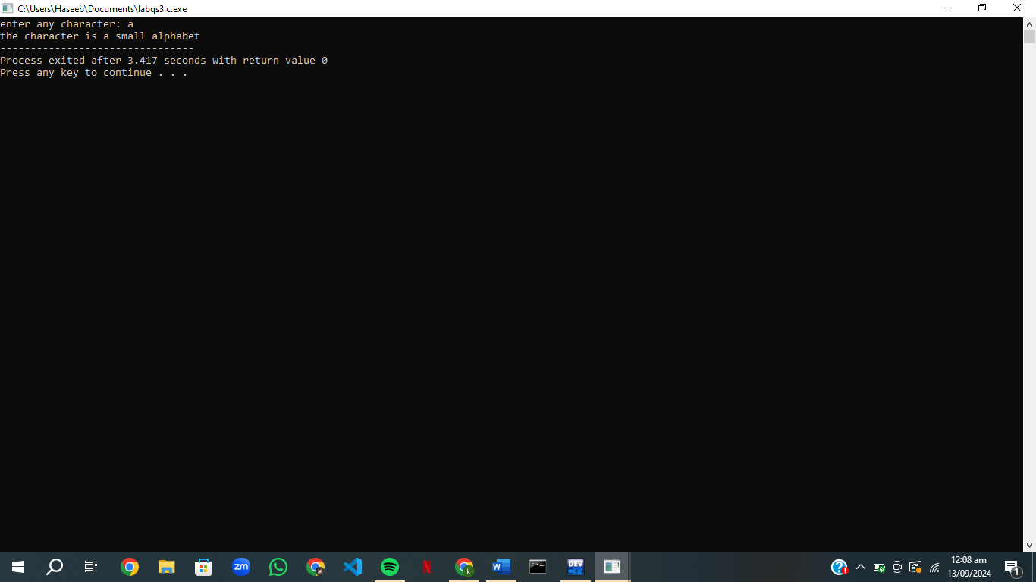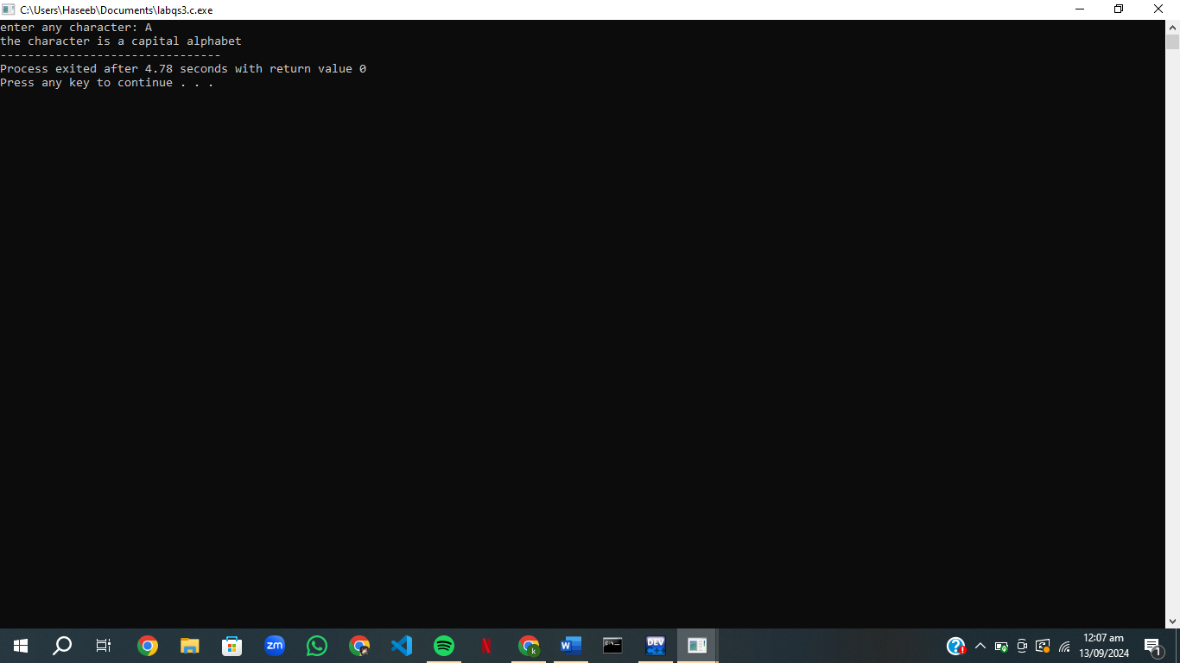

start

It is a special character

is it a number

Is it a capital letter

is it a small letter

Enter a character

it is a small letter

It is a small letter

end

It is a number

YES

NO

YES

NO

YES

NO

# Qs.4 Store discount

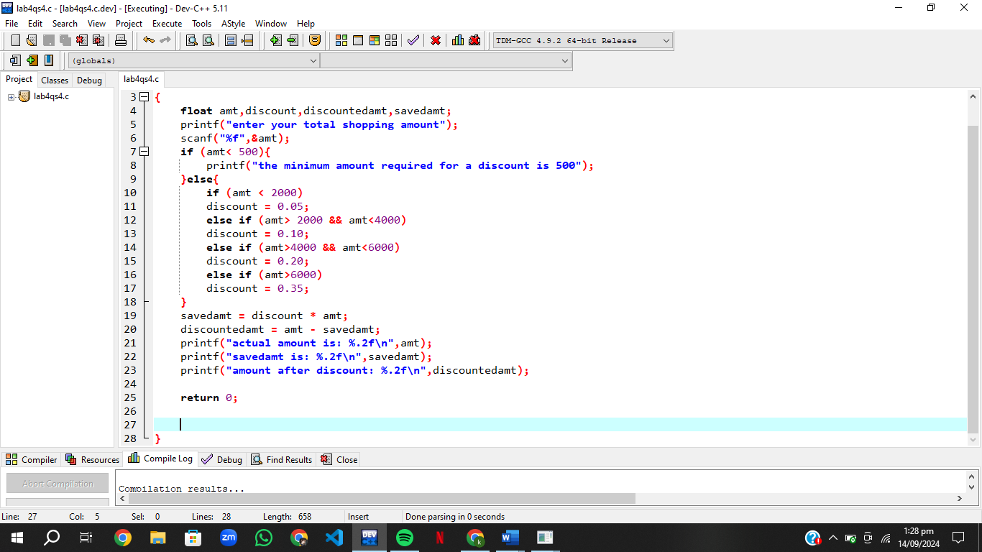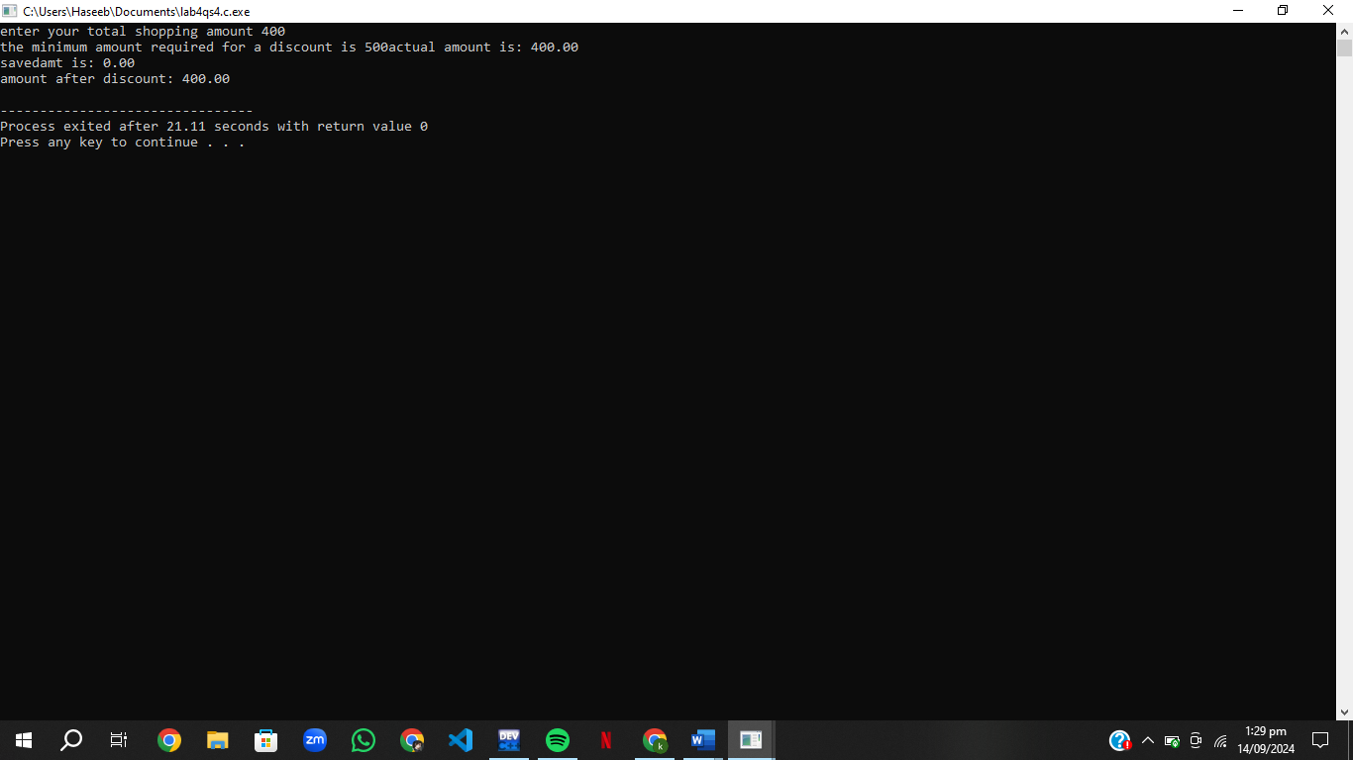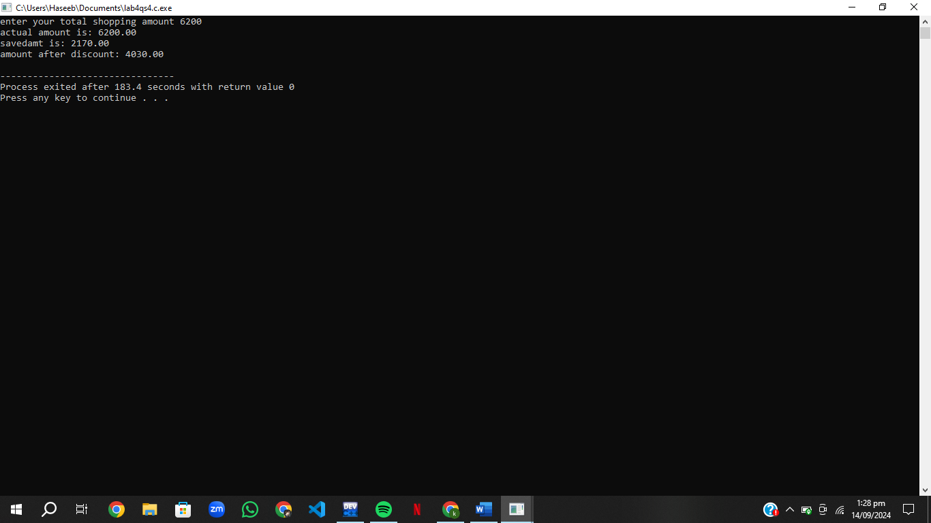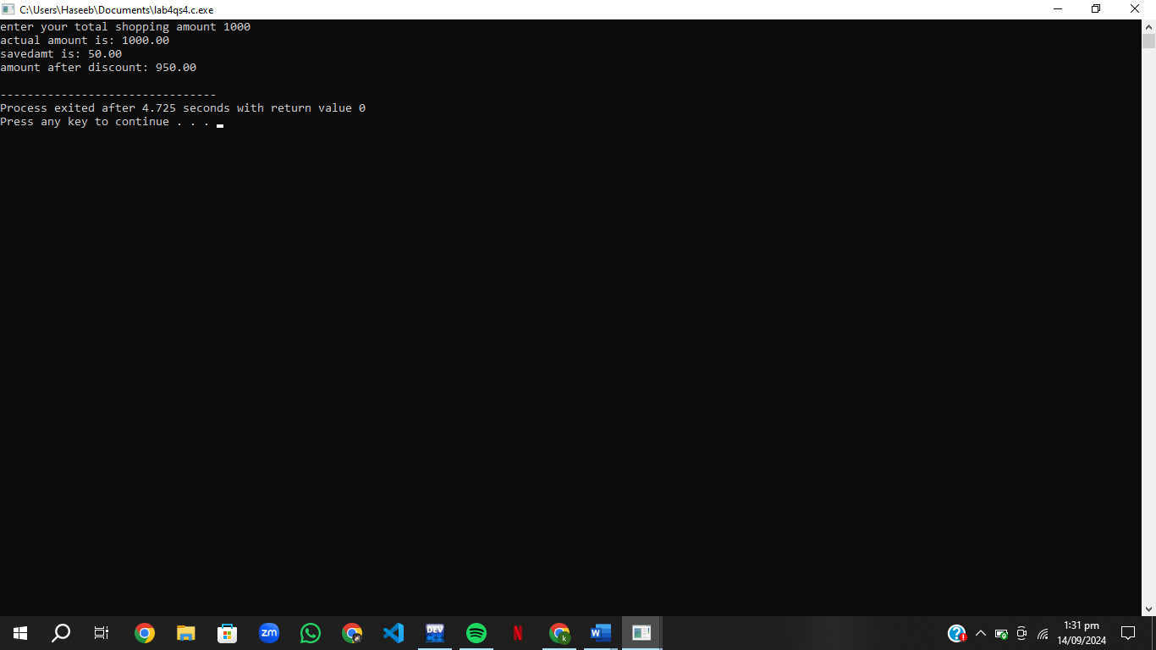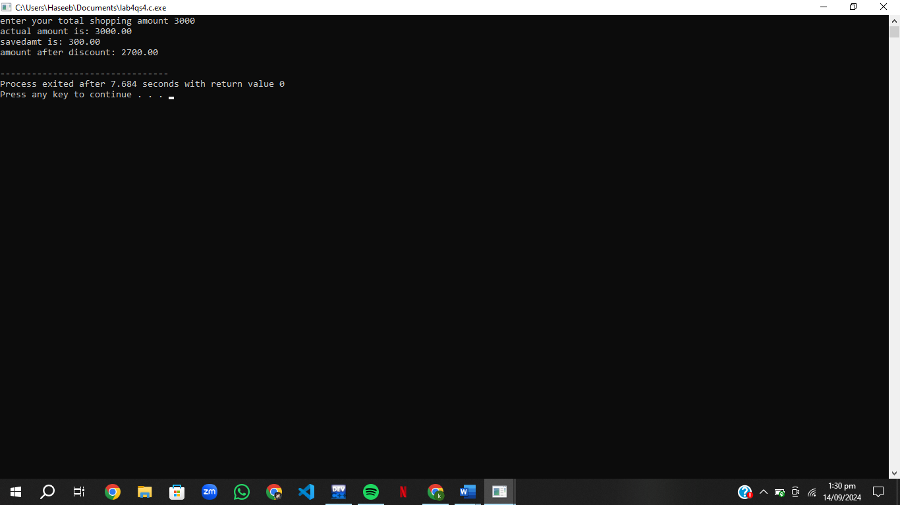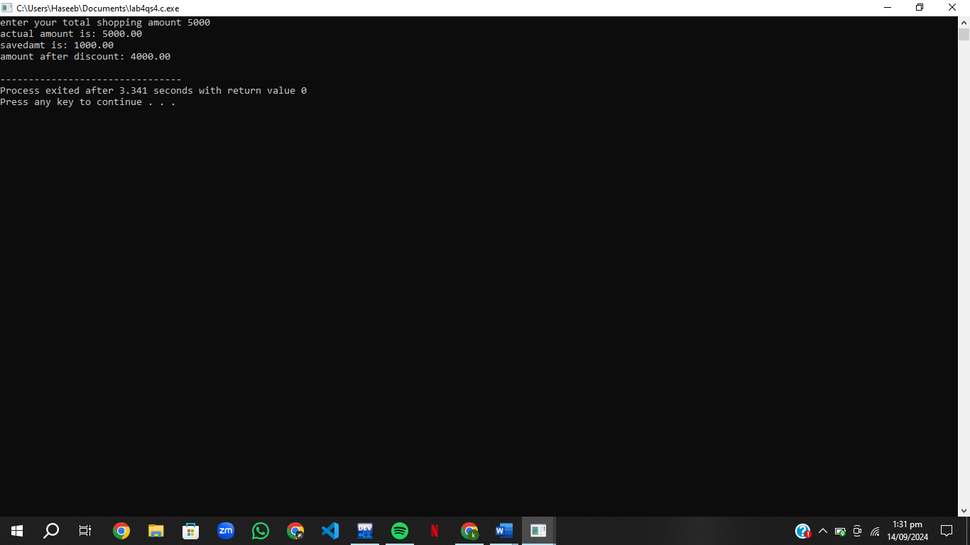

Minimum amount for discount is 500

Is amt>500

Enter your shopping amount

end

NO

YES

Savedamt = amt*0.05

Is amt<2000

YES

NO

Savedamt = amt*0.20

Is amt>6000

Savedamt = amt*0.20

Is amt>4000 AND amt<6000

Savedamt = amt*0.10

Is amt>2000 AND amt<4000

YES

NO

YES

NO

YES

Savedamt=amt*discount

Discountedamt=amt-savedamt

OUTPUT

Savedamt,amt,discountedamt

END

# Qs.5Electricity Bill

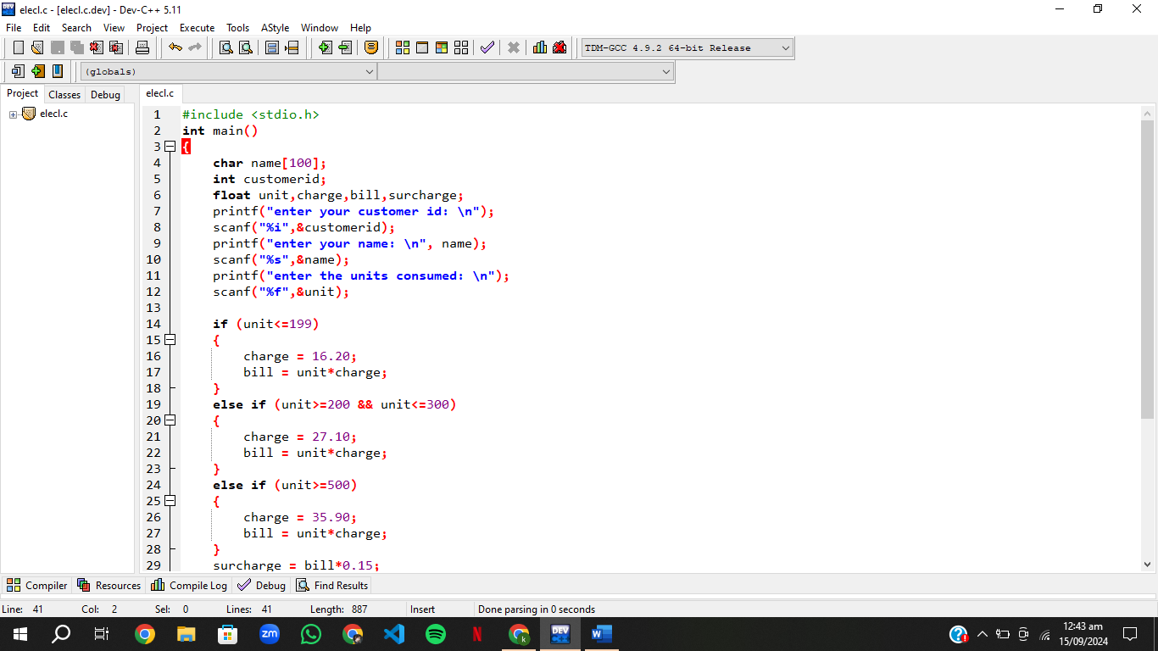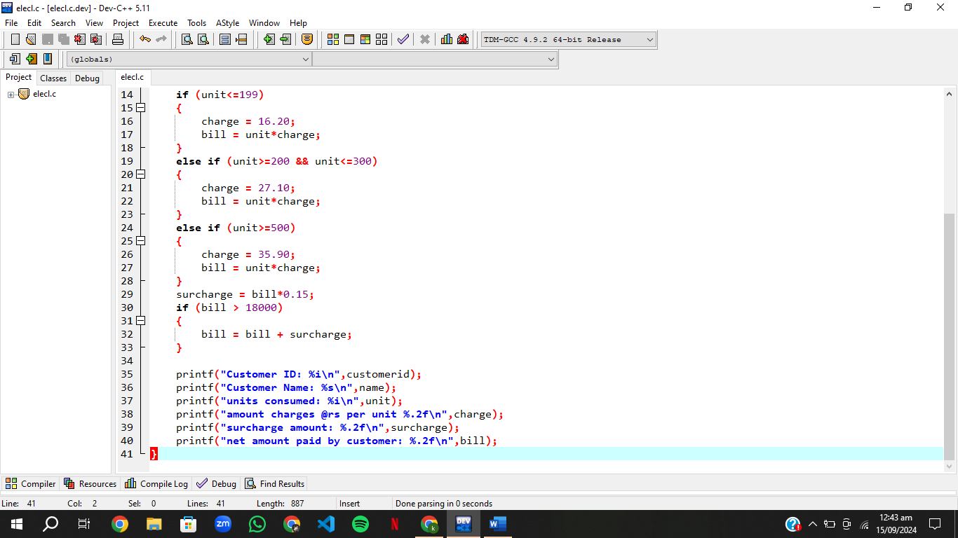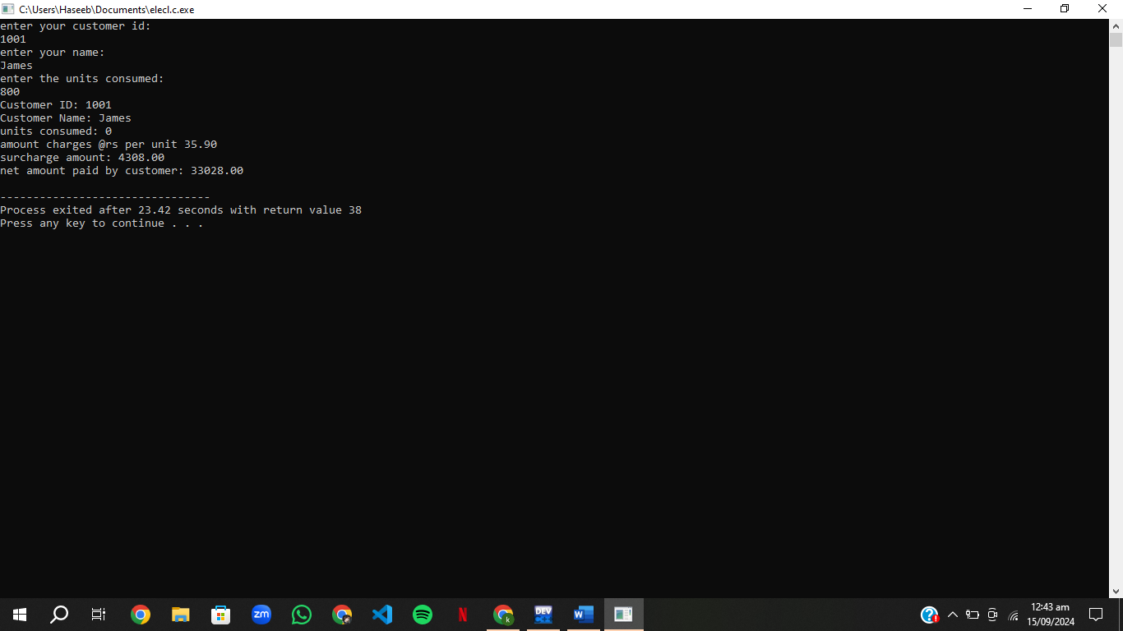

start

Bill = units*20.10

Is units>=200 AND units<=300

Bill = units*16.20

Are units <=199

Input customer ID, name, Units consumed

Are units>=300 AND units<=500

Bill = units*27.20

Bill = units*35.90

Is units>=500

Surcharge=bill*0.15

Is bill>18000

Bill = bill + surcharge

Customer name,id,units,bill,surcharge,unit price

end

# Qs. 6 Number output

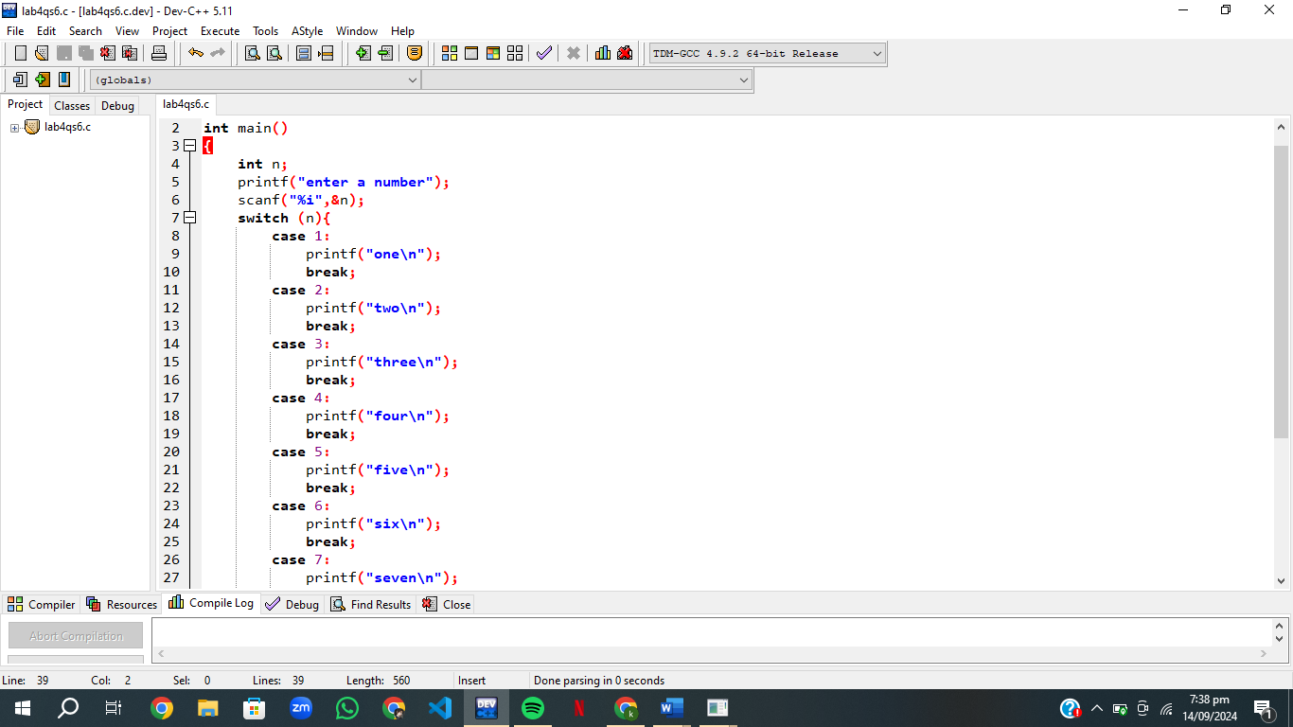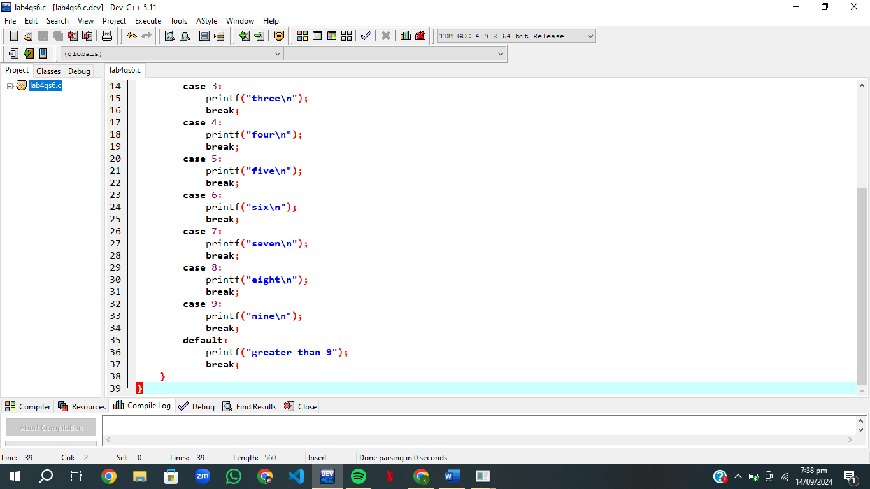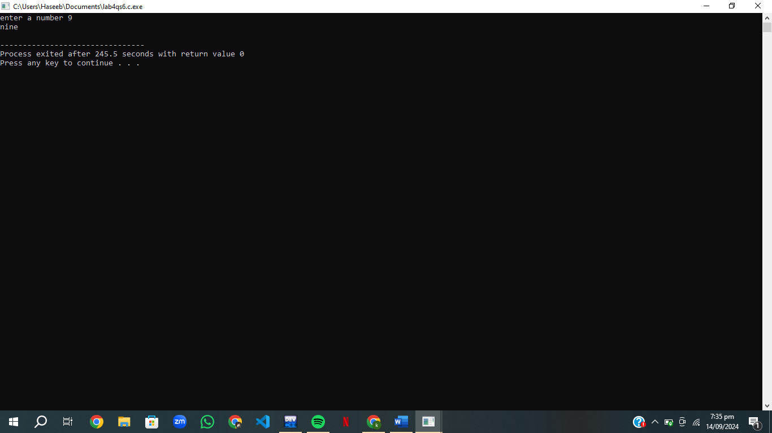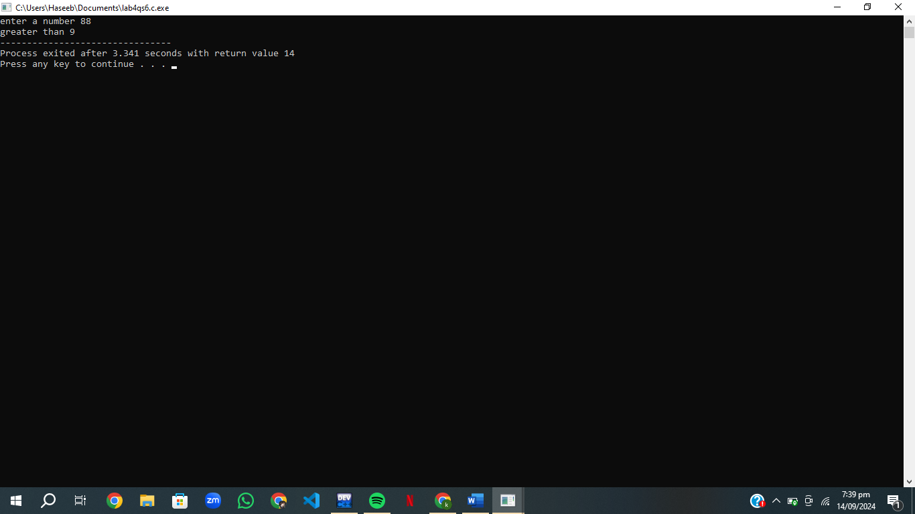

# Qs.7 Auto brightness

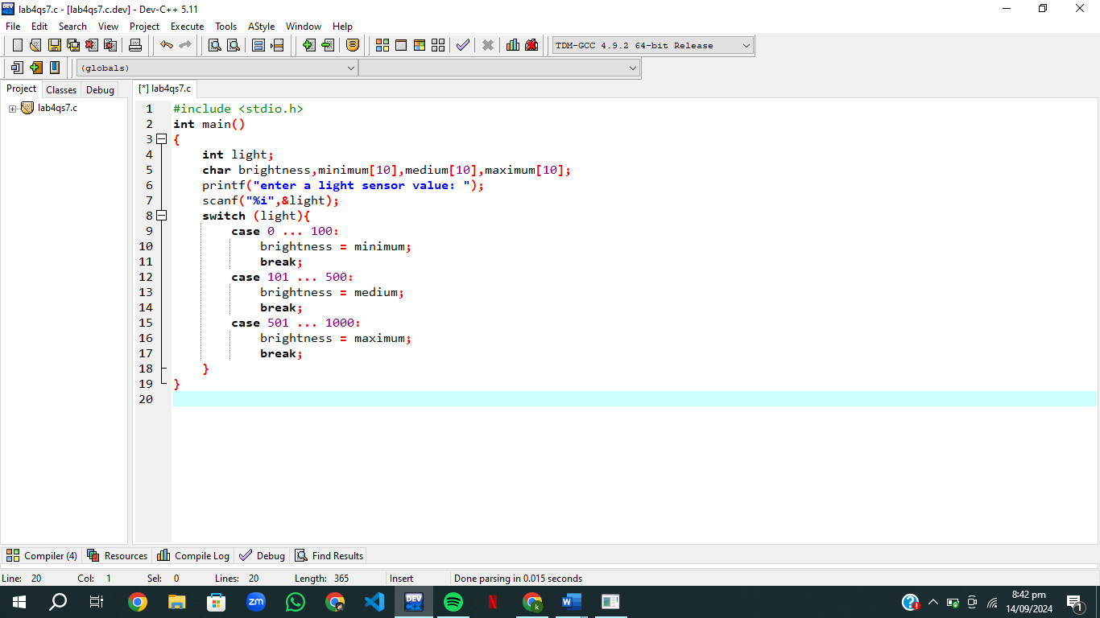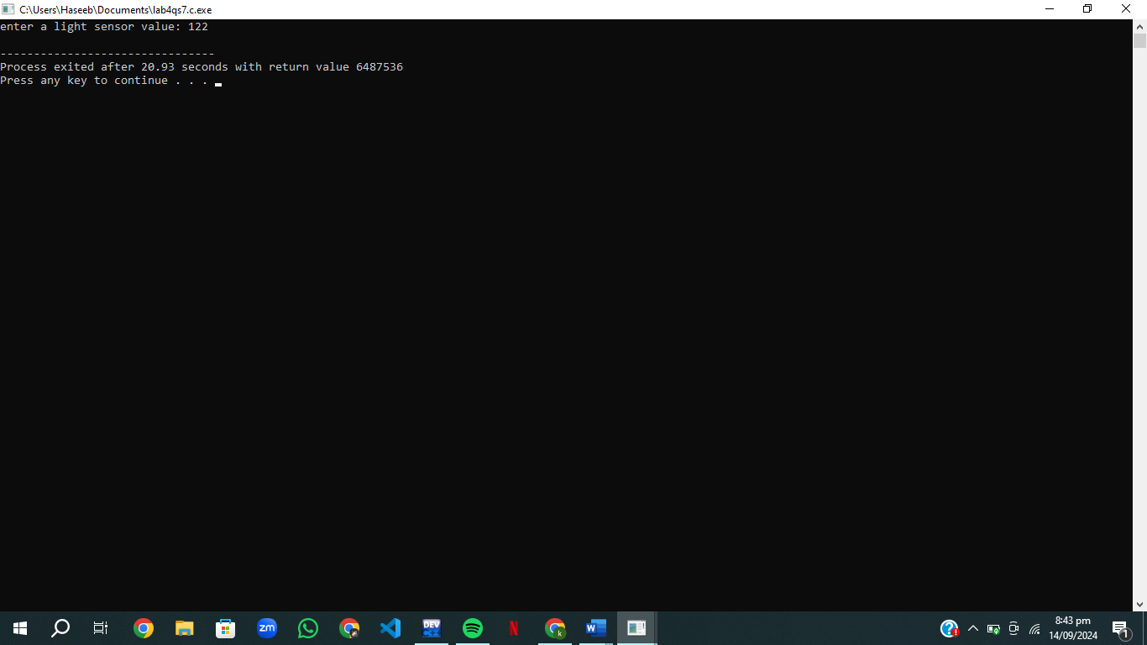

# Qs.8 Greetings

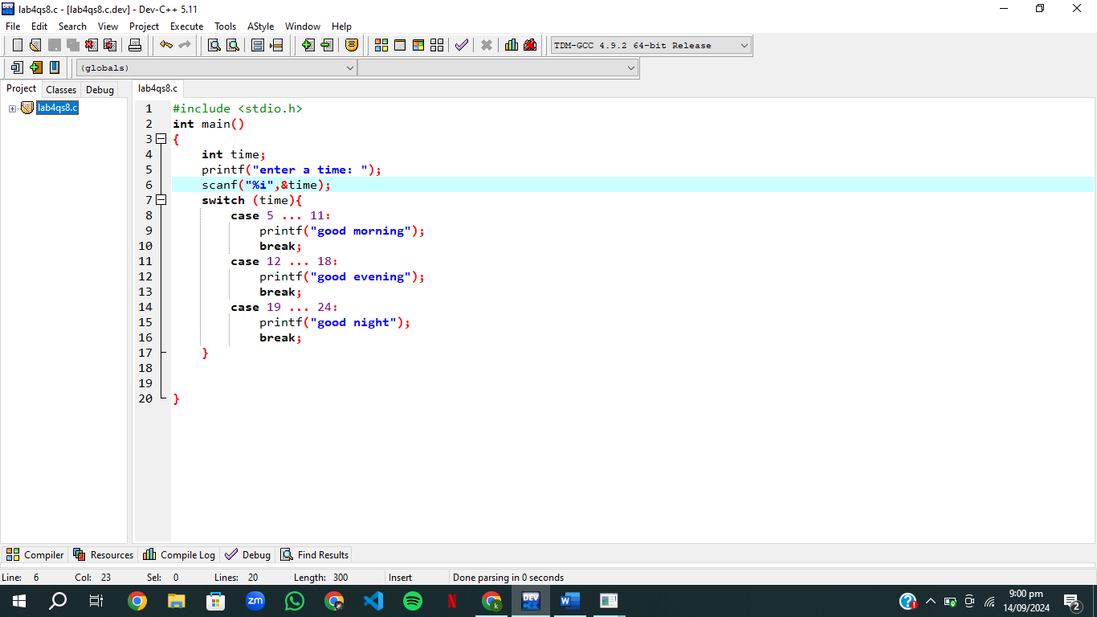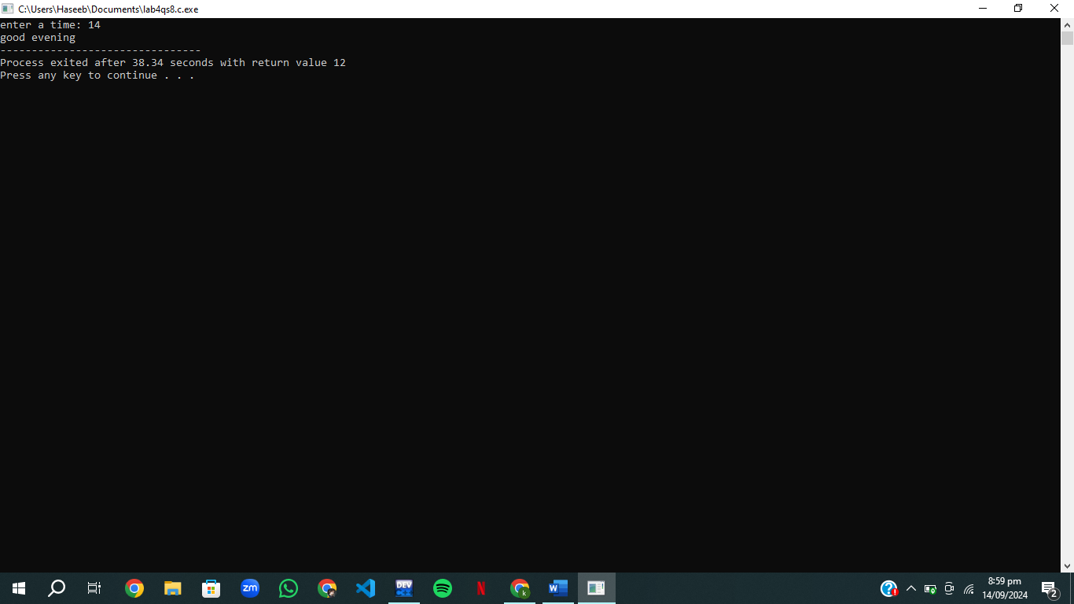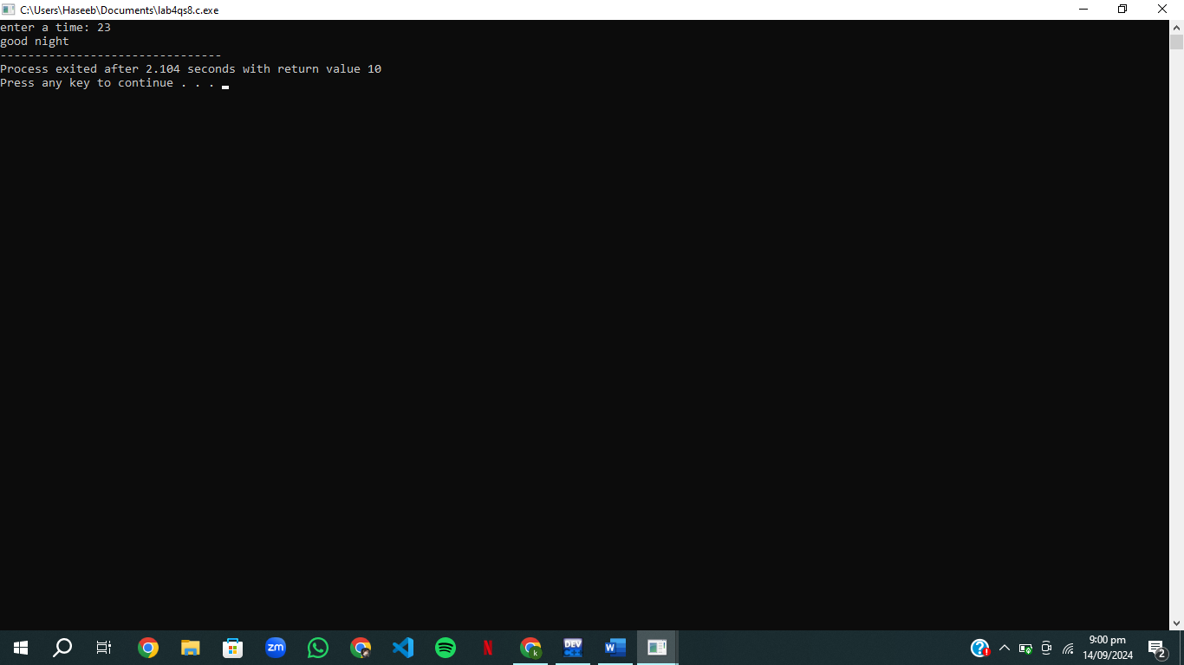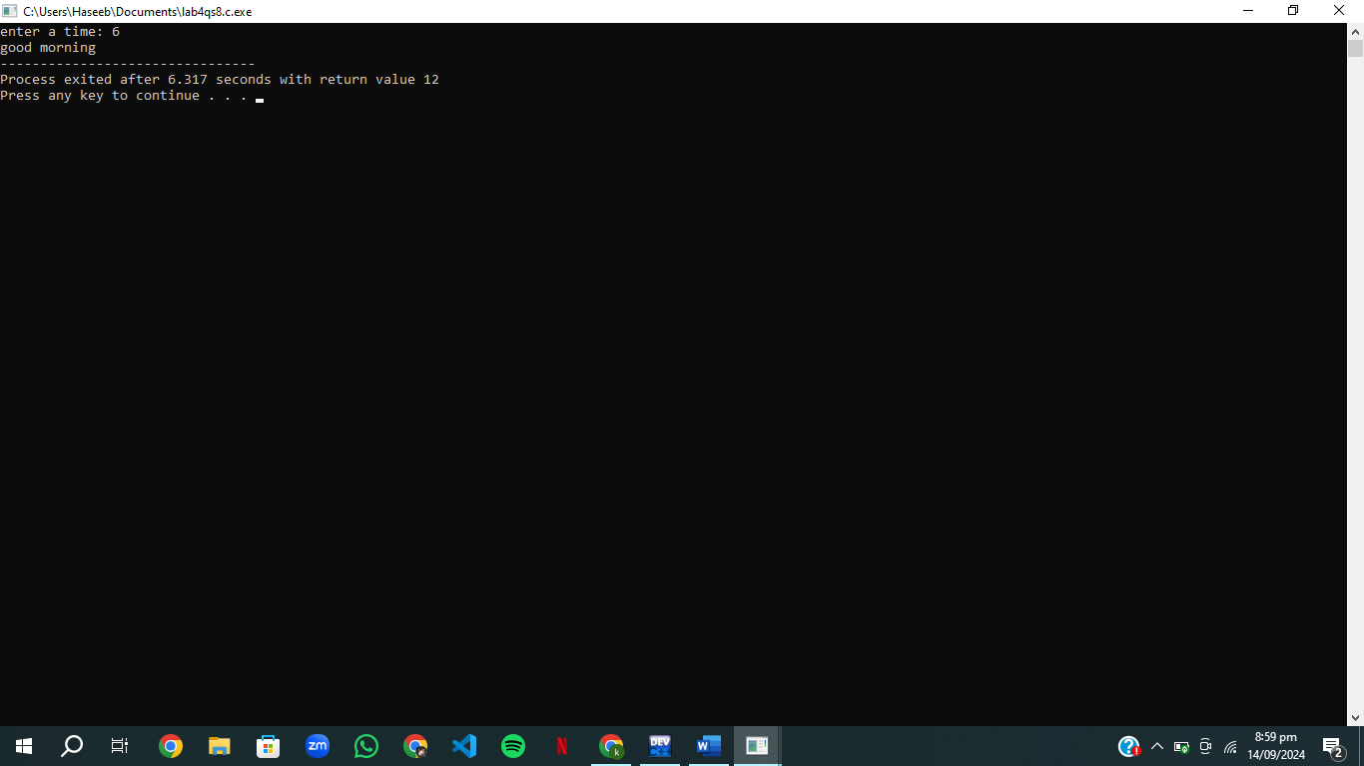

# Qs.9 University eligibility

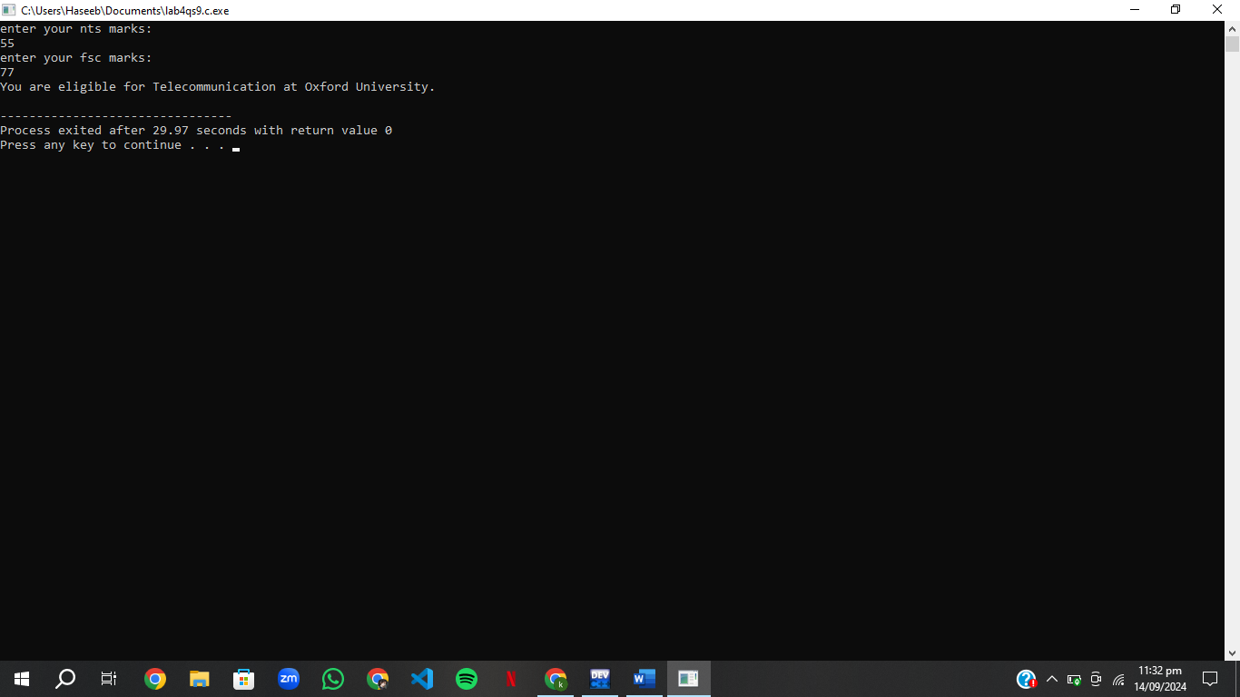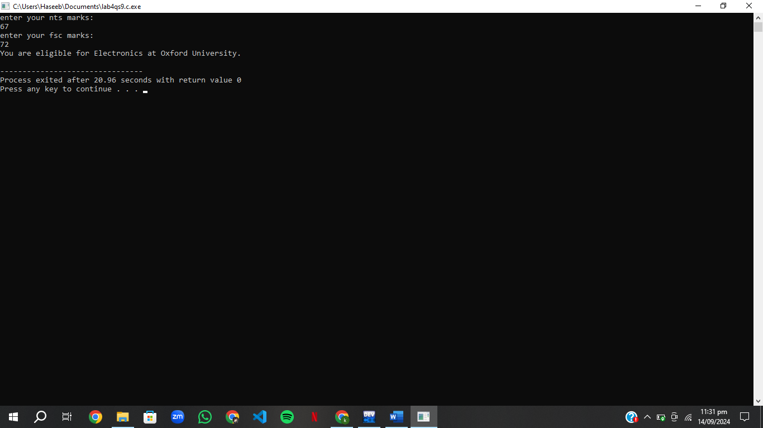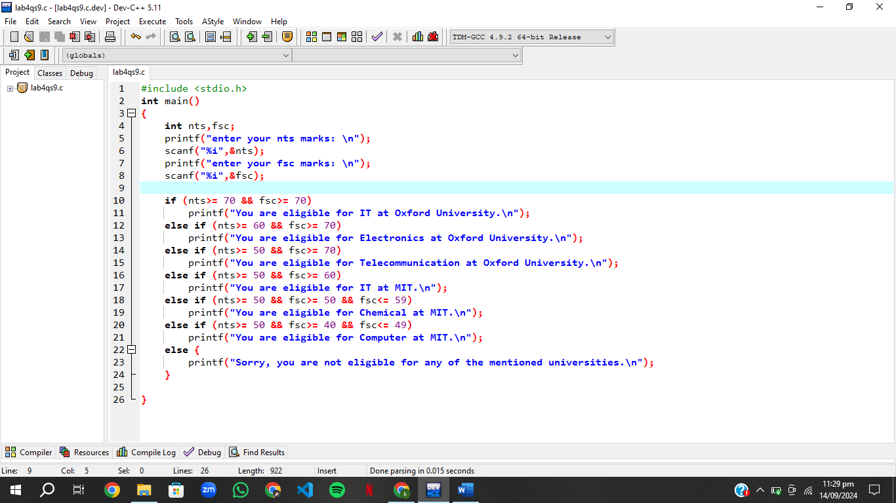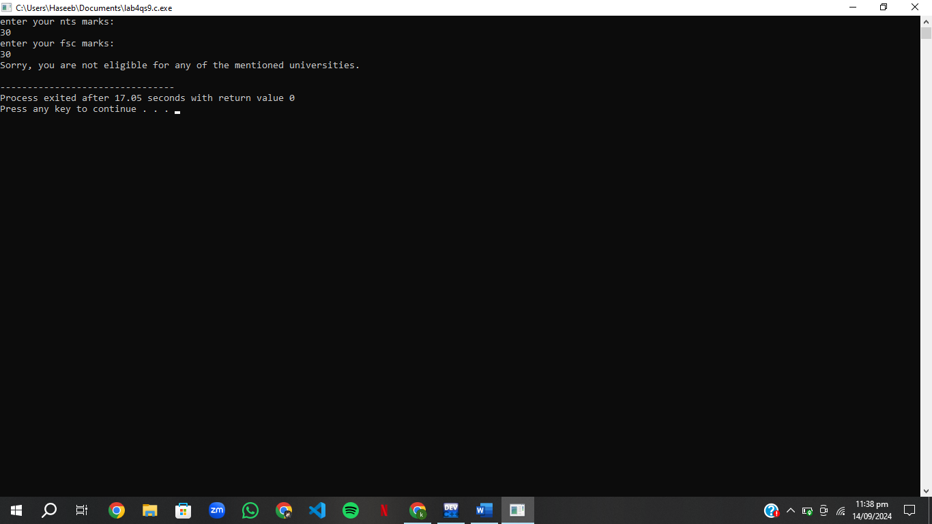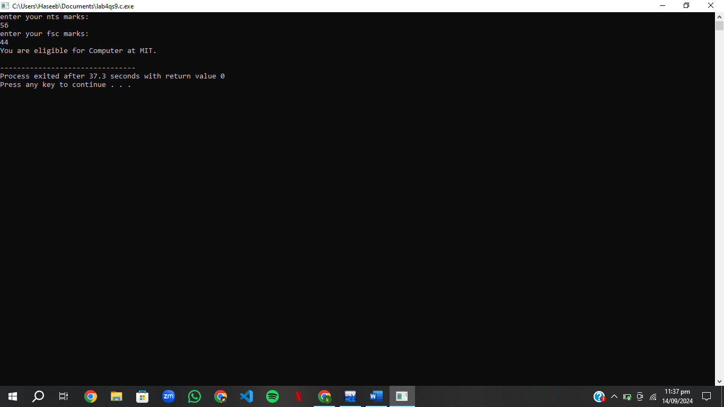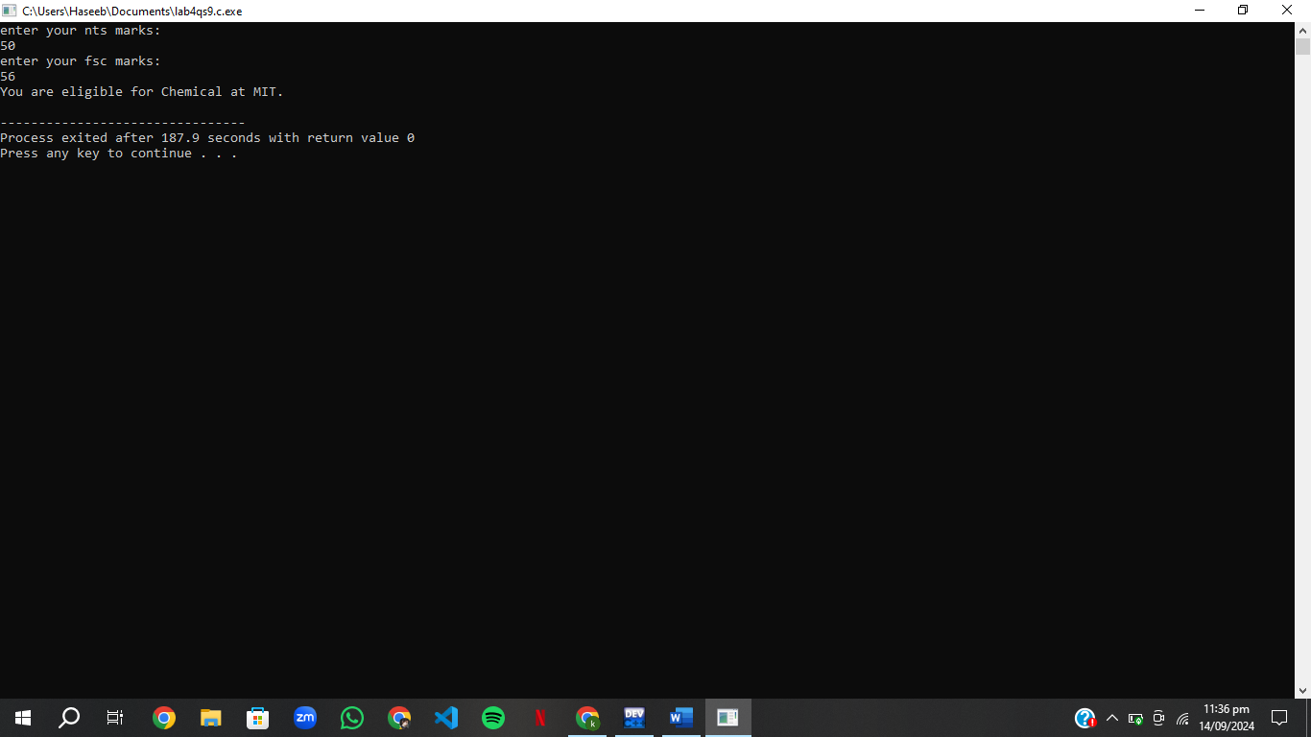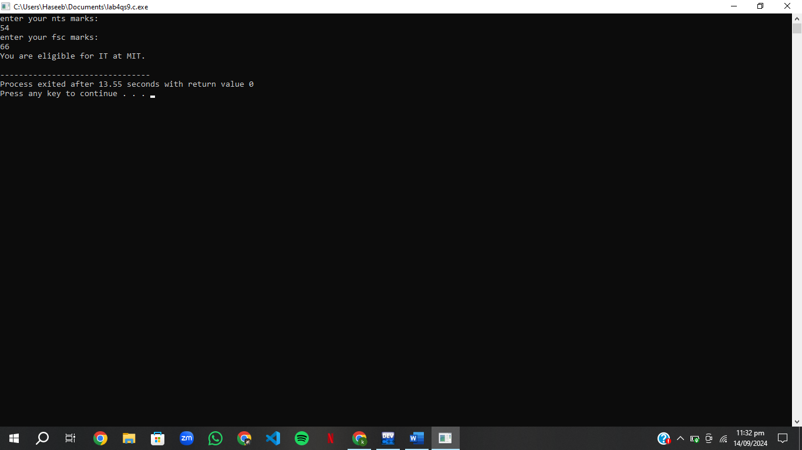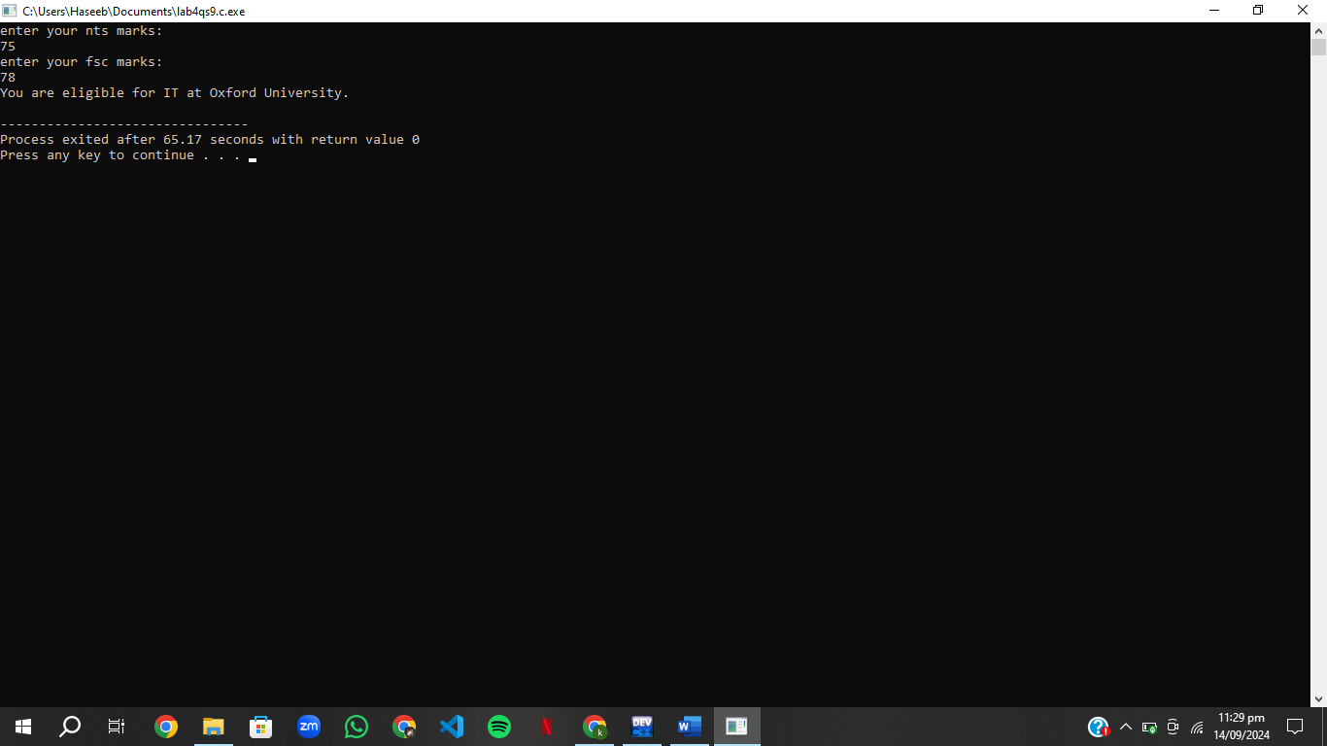

# Qs.10 temperature

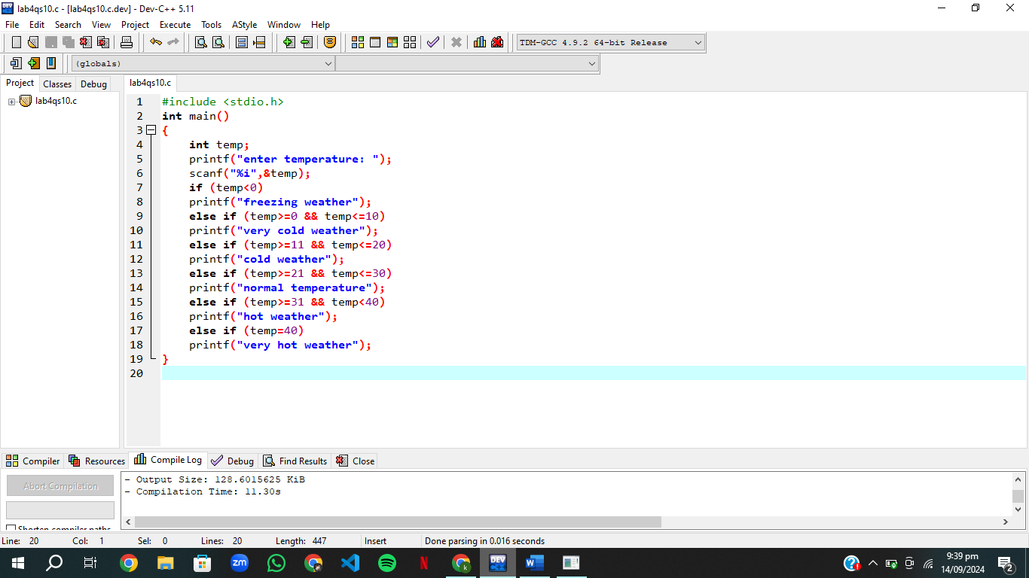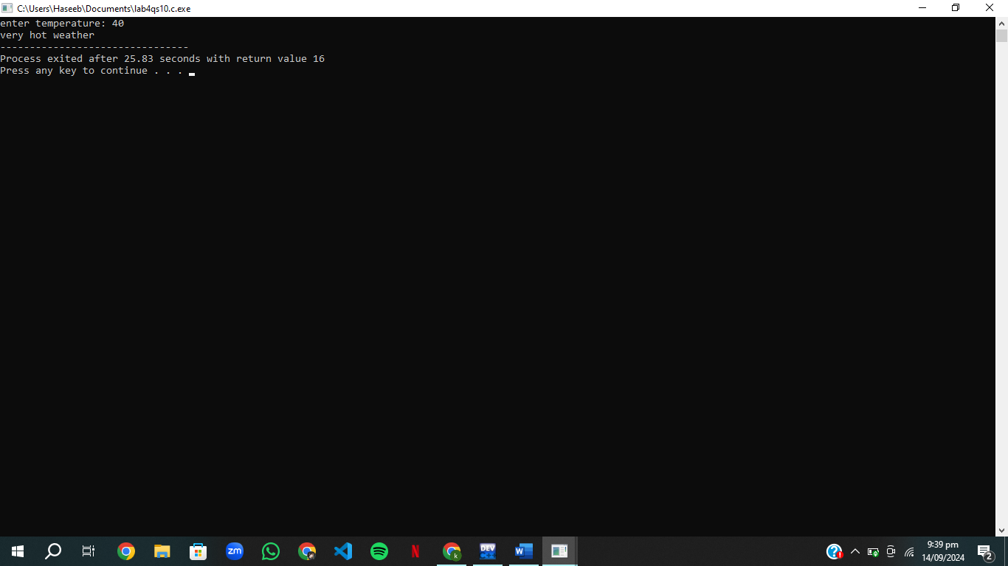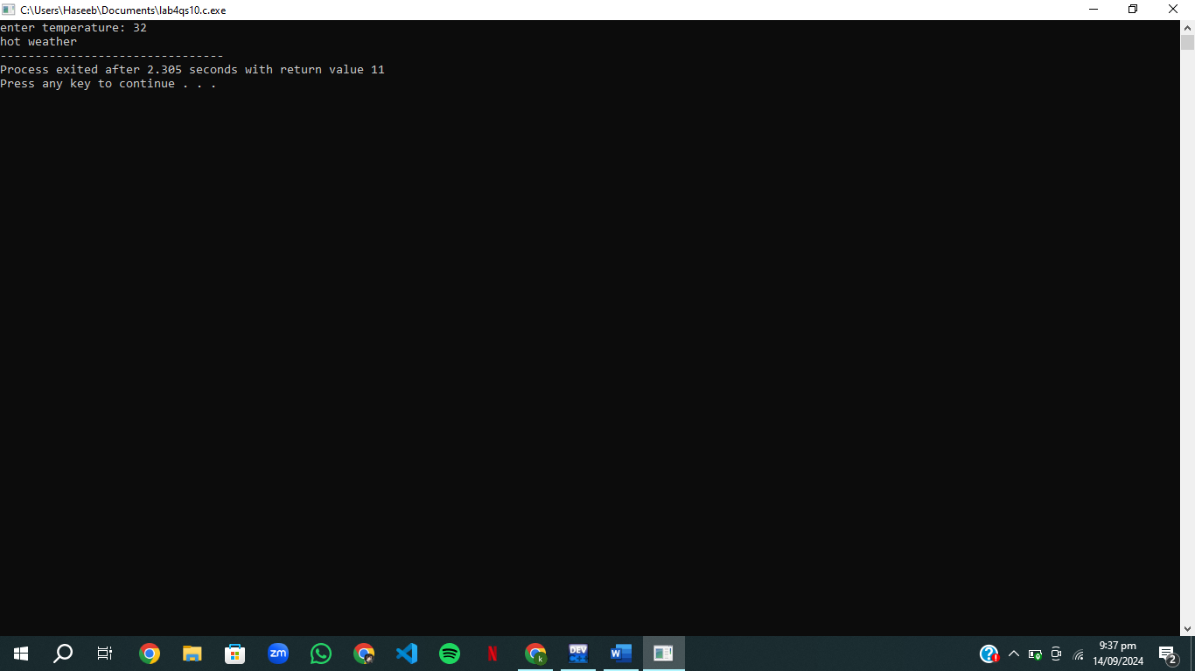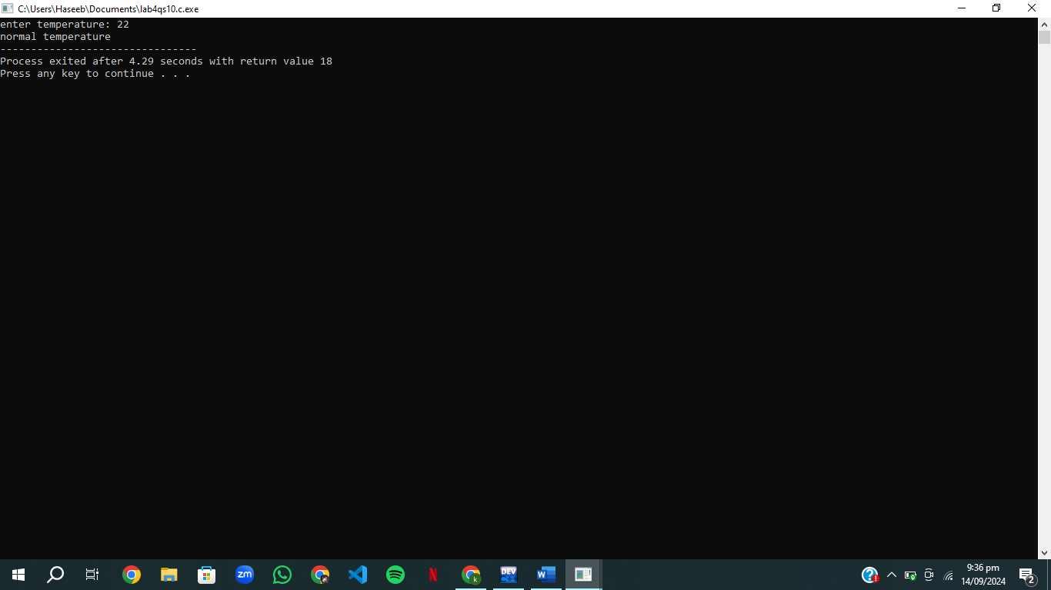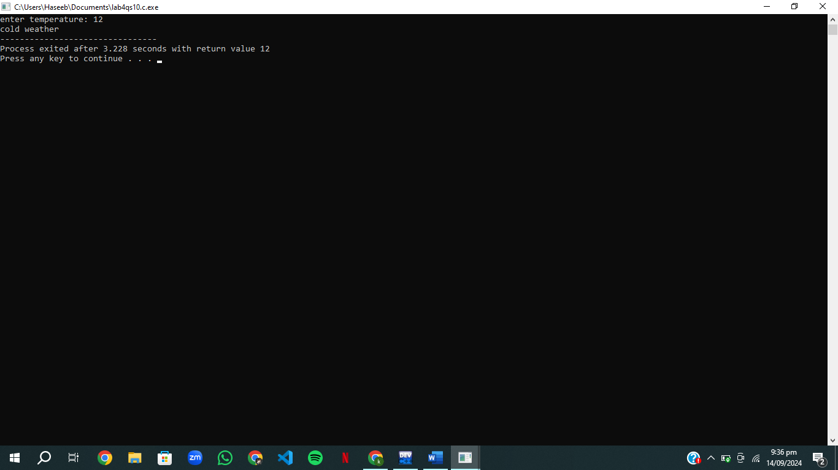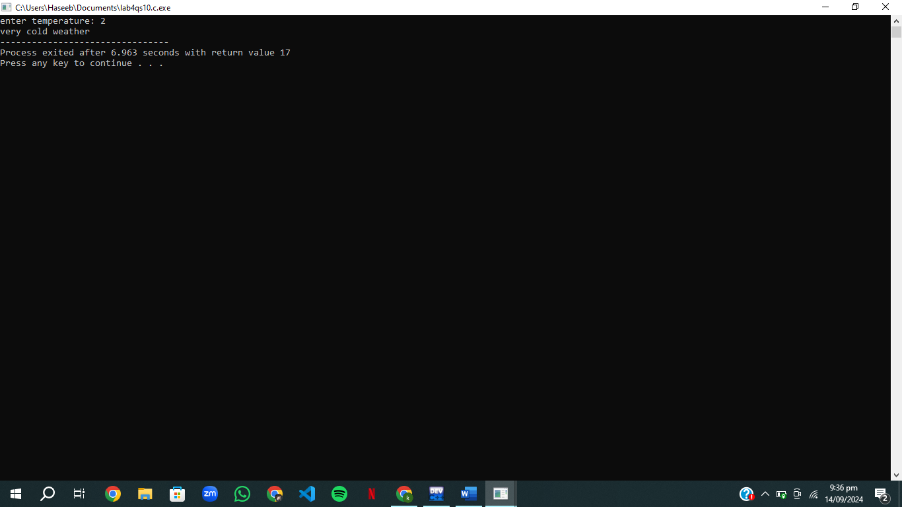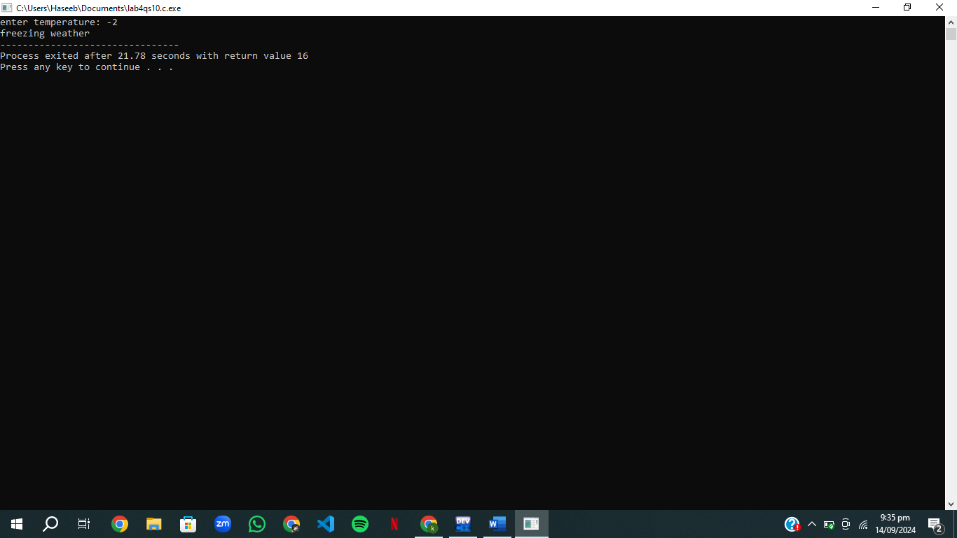

# Cw qs

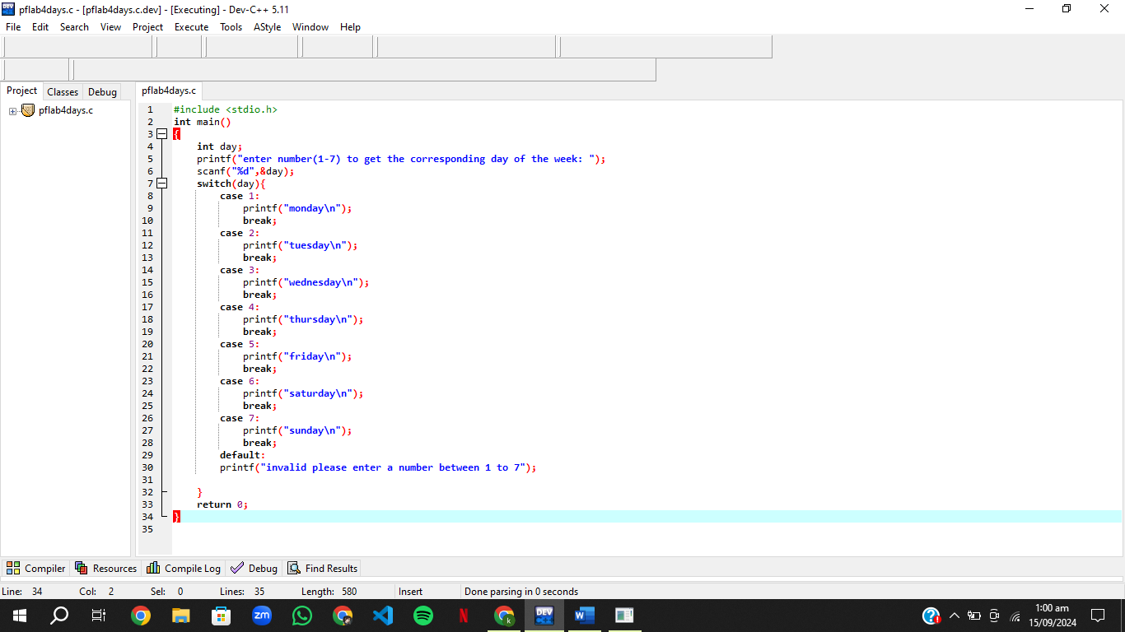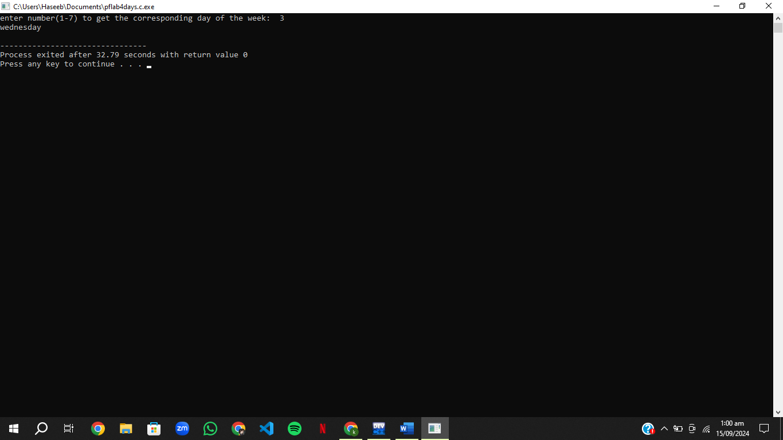

# Cw qs 2

